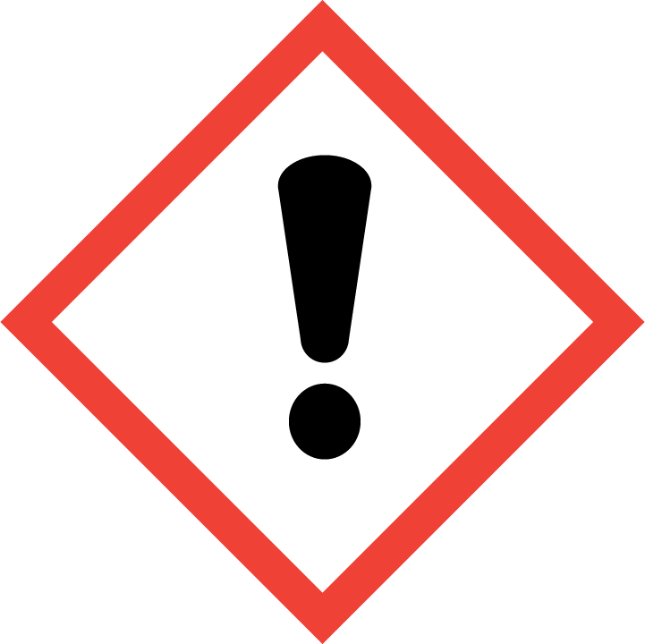
HARMFUL OR IRRITANT

